



**Course title:** Numerical Methods.

**Assignment on:** Symbolic Relations and Separation of Symbols.

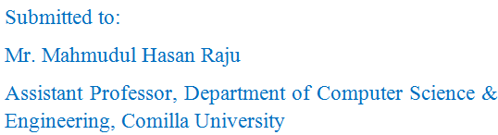

Date of Submission: 16-03-2016

Submitted by:

